Q. WRITE A PROGRAMME TO READ A CHARACTER AND CHECK WHETHER IT IS AN VOWEL OR CONSONENT

A.# include<stdio.h>

int main()

{

char x;

x=0;

printf("enter a alphabhet...:");

scanf("%C",&x);

if (x=='a'||x=='e'||x=='i'||x=='o'||x=='u'||x=='A'||x=='E'||x=='I'||x=='O'||x=='U')

printf("it is an vowel");

else

printf("it is an consonent");

}

Output:

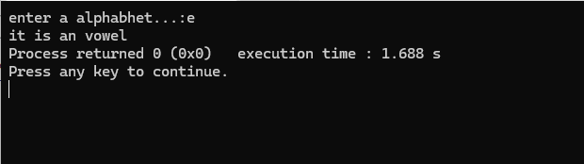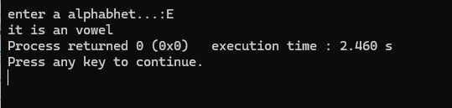

Q.WRITE A PROGRAMME TP READ A CHARACTER FROM THE USER AND DISPLAY THE MESSAGE CONTINUE IF INPUT IS OTHER THAN X,IF X THEN DISPLAY STOP

A. # include<stdio.h>

int main()

{

char y;

y=0;

printf("enter an alphabet...:");

scanf("%c",&y);

if(y=='X'||y=='x')

printf("STOP");

else

printf("continue");

}

OUTPUT:  
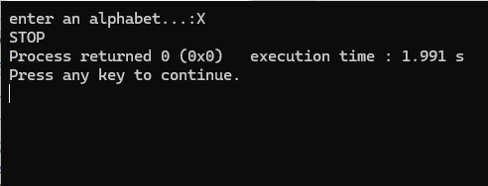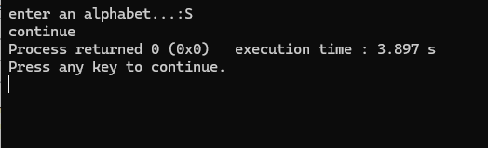

Q.WRITE A PROGRAMME TO CHECK IF THE PERSON IS ELIGIBLE TO GET A BONUS BASED UPON THE FEW CRITERTIA

# include<stdio.h>

int main()

{

char martialstat,gender;

int age;

printf("martial status(if married press M,else press U.:");

scanf("%c",& martialstat);

if(martialstat=='M')

printf("you are elgible for bonus");

else

{{

printf("enter your gender (if male press m,else press F..:");

fflush(stdin);

scanf("%c",&gender);}

if(gender=='m')

{

printf("\nenter your age ...:");

scanf("%d",&age);

if(age>=30)

printf("you are elgible for bonus ");

else

printf("you are not eligible for bonus");

}

else

printf("\nenter your age ...:");

scanf("%d",&age);

if(age>=25)

printf("you are elgible for bonus ");

else

printf("you are not eligible for bonus");}

}

Output:

